Ex Cathedra Scholars
Information & application pack 2026-27

“...it is the community of friendly, helpful and incredibly talented musicians that makes Ex Cathedra so distinctive. The unique combination of scholars, amateur singers and world-class professionals creates such an interesting and comfortable work environment... I have been able to absorb so much new knowledge.”
(Ellie Stamp, 2023-24 Scholar)

What is it: A year-long choral Scholarship, worth up to £4500 paid in equal monthly instalments, for the UK’s very best recent graduate singers.

Am I eligible? If you are completing your degree this summer or have finished in the past 2-3 years, you are not continuing in education, and you are seeking to develop a career as a professional singer

Apply by: Wednesday 27 May 2026, 12pm

Complete the application form and indicative availability sheet, and return with a reference from your singing teacher or equivalent

Auditions: Thursday 18 June – CBSO Centre, B1 2LF (save all day)
The day will include group workshops as well as an individual audition, so please save the whole day for now, and let us know with your application form if there is anything you need us to try and accommodate.

If you are shortlisted, we will communicate the timetable to you on or by Thursday 04 June 2026.

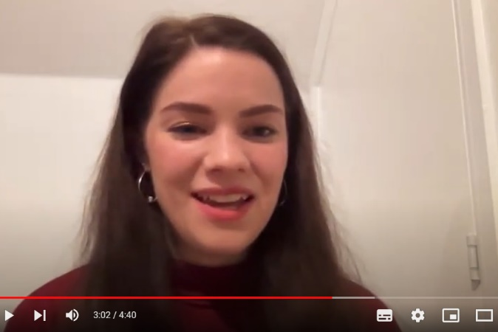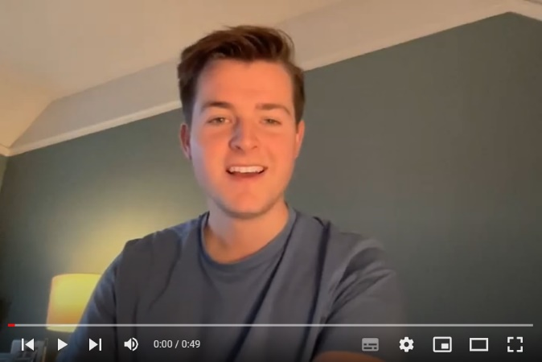
Two former Scholars have recorded short videos, explaining how their year with Ex Cathedra helped them. Click each image to watch, or the links below:

- Margaret Lingas: https://youtu.be/ZQdoJwvIKrg
- Sebastian Hill: https://youtu.be/4Ys8PO_BqJw
About Ex Cathedra

Hailed as “one of Britain’s very best choirs” (New York Times), Ex Cathedra is a world-class vocal ensemble which leads the choral sector in the fields of performance, learning and wellbeing.

For more than 50 years we have been producing highly acclaimed concerts and participatory projects, and nurturing young musicians from our youth training choirs to our Scholar schemes.

We enjoy an international reputation for our performances of the best, the unfamiliar and the unexpected, and take pride in developing the repertoire through researching and reviving little-known gems, commissioning new work, and developing exciting ways of engaging audiences and participants. We perform amongst the widest repertoire of any professional choir in the country - repertoire reaches from Palestrina to Bach, Handel, Rachmaninoff, Bacharach, alongside Alec Roth and Liz Dilnot Johnson, our composers-in-residence.

Jeffrey Skidmore founded Ex Cathedra in 1969, and his track record of identifying and nurturing young singers is unrivalled. The list of singers who credit Jeffrey and Ex Cathedra for supporting their early career includes Carolyn Sampson, Paul Agnew (Associate Musical Director of Les Arts Florissants), Nigel Short (Tenebrae), Benjamin Hulett, Andrew Tortise, Marcus Farnsworth, Samuel Boden, Patrick Dunachie (Kings Singers), Nick Ashby (Kings Singers) and many more. Around half of our recent Scholars now sing regularly with Ex Cathedra as established professional singers, including as soloists in our main season.

We’re delighted to invite applications for the sixth year of our Scholarships scheme. You can read more about former and current Scholars on our website, several of whom now work with us regularly as professional singers and as soloists.

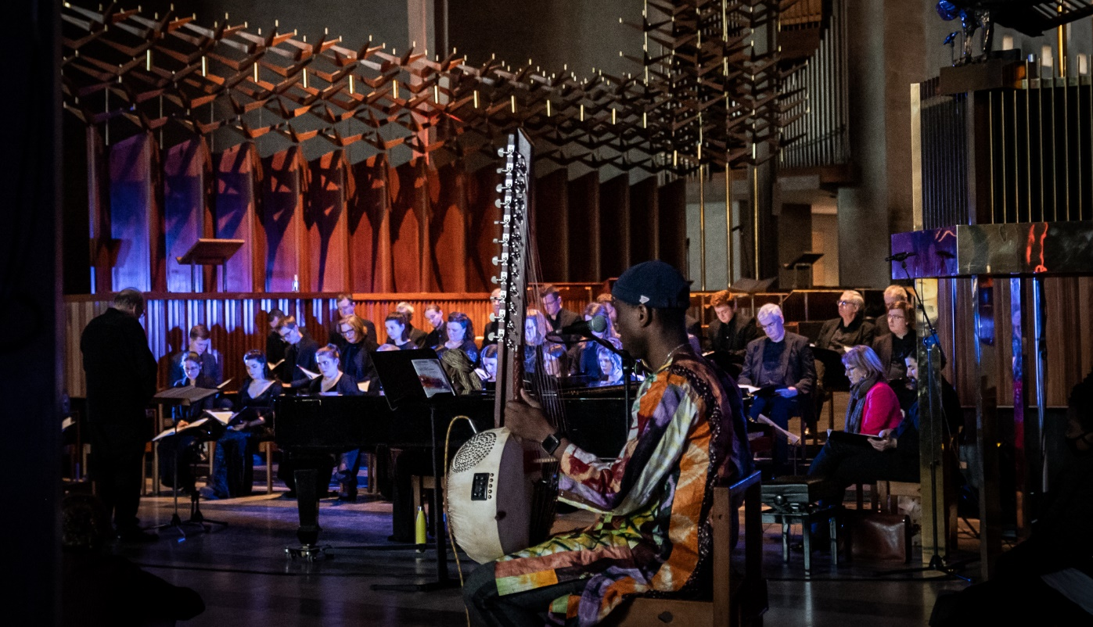
Ex Cathedra performs Liz Dilnot Johnson’s “When a Child is a Witness”, co-created with refugee communities, Feb 2022 at Coventry Cathedral as part of the City of Culture programme.
Kadialy Kouyate is the kora soloist in the foreground.

What we offer

Successful candidates will receive guaranteed payment of £4500, paid in equal monthly instalments. A pro rata amount may be negotiated if your availability is limited. We seek to offer the scholarship opportunity to people who are able to give full availability. Commitment and payment schedules will be monitored and reviewed throughout the year, and we reserve the right to adjust payments later in the year if attendance significantly reduces. Additional paid work may be offered during the year and beyond.

You will gain real life experience of working with a professional choir, including time and diary management, and develop your singing in a professional and supportive environment by:
- rehearsing and performing a wide range of repertoire stylistically, learning the different approaches required as you take part in all our full choir performances and recordings
- observing rehearsals and concerts given by our Consort of 10 professional singers, who you will sing alongside in choir concerts
- observing soloist rehearsals
- attending termly one-to-one feedback sessions with Jeffrey Skidmore
- observing our Vocal Tutors as they deliver projects in schools and healthcare environments

Our aim is that the scheme will accelerate your professional development and increase your chance of being offered professional work by Ex Cathedra and other choirs. By working alongside and learning from some of the UK’s finest professional singers, you should develop an invaluable network of contacts and raise your profile within the industry.

Watch the videos linked on page 1 to see what two former Scholars think.

Our 2026-27 season includes: Bach & Sandstrom motets with Artistic Director Designate, James Burton, Missa Solemnis with world-class guest soloists and the City of Birmingham Symphony Orchestra, a Good Friday Bach St Matthew Passion with period instruments at both Bristol Beacon and Symphony Hall, Monteverdi Vespers in Birmingham Oratory and magical anthology concerts that range from Byrd to Bacharach, with pretty much everything in between!

“The graduate scholarship provided the perfect bridge between training and professional work, and a safe space to try new things and develop the skills needed for professional music making...”

(Lucy Ormrod, 2025-26 Scholar)

Your commitment

If you are offered and accept a Scholarship, we will send you a contract setting out our expectations. Key points:
- you are expected to complete the year and make the most of the opportunities provided!
- you must attend the c.25 rehearsals and c.20 concerts over the course of the year, which will be agreed with you and provided in a work schedule appended to your contract if offered the position. Provisional dates are available below
- you must attend a termly feedback session with Jeffrey Skidmore
- you are expected to attend the Scholars Ensemble rehearsals, as detailed in the work schedule, held at Royal Birmingham Conservatoire (these usually align with Ex Cathedra rehearsals)
- you will be provided with complimentary tickets and encouraged to attend concerts that you are not performing in, and may be asked to help out with CD sales, stewarding etc
- to write 1-2 short accounts of your experience during the year that we can use in fundraising reports and applications
- to commit to acknowledging your Scholarship with Ex Cathedra in your professional biography as your career progresses
- to satisfactorily complete our Safer Recruitment checks (see below)

Aside from these commitments you are encouraged to build up your portfolio of other work.

Who is eligible

You must be eligible to work in the UK as Scholars will be employed on a fixed term contract.

To apply:
- we expect you will be about to embark or have embarked on a career as a professional singer within the last 2-3 years
- normally you will have studied or are about to complete a degree-level course in music with singing lessons
- or, exceptionally, you have recently changed career to focus on being a professional singer

If you are in full-time or part-time education (undergraduate or postgraduate), you are not eligible to apply unless you will have completed your course by the time your Scholarship starts. If you are studying at the Royal Birmingham Conservatoire do take a look at our Student Scholarship scheme, which is assessed alongside an audition for the Conservatoire chamber choir, and if you are currently studying at the University of Birmingham, take a look at their Student Scholarship scheme.

Given the extensive work we do with children and vulnerable adults you must also satisfactorily meet our Safer Recruitment requirements. This includes a self-declaration questionnaire and DBS check. Offers will only be confirmed once this process is complete.

If you have any questions about any of this, please contact us to discuss. In the first instance, please email melissa.brown@excathedra.co.uk and we can arrange a telephone call, if preferred.

How to apply

1. Please supply:
- A completed application form and the indicative availability sheet
- A reference from your current (or most recent) singing teacher or equivalent (choral director etc.)

Ex Cathedra is committed to a policy of equality of opportunity in its employment practices, and values diversity. To help us monitor and improve our ability to attract a range of applicants, we encourage applicants for performer, staff and trustee vacancies to complete our Equality and Diversity Monitoring Form, which is anonymous and not part of the selection process.

Applications must be submitted by midday on Wednesday 27 May 2026. Late entries and incomplete applications are unlikely to be accepted.

2. Audition & workshop day

Shortlisted candidates will be invited to attend our workshop and audition day on Thursday 18 June 2026 in Birmingham. Please reserve the date in your diary. On this day you will take part in a group session and have an individual audition. Please save the whole day for now and contact us ahead of your application if you have any limiting time issues so we can advise.

We will let you know whether or not you are invited to attend for an audition on or by Thursday 04 June and will let you know then what times you will be required.

The audition and workshop day is designed to be friendly and welcoming. Depending on the final timetable, it is likely that everyone will have a shared lunch break with lunch provided.

SCHOLARS SCHEME 2026-27- APPLICATION FORM

Name:
Address:
Email: |  | Age at application:  (20-23 / 24-29 / 30-39 / 40+)
Phone: |  | Voice (SATB):
University/College:
Graduation date: |  | Degree obtained/expected:
Current singing teacher: |  | Confirmation that you agree to our Safer Recruitment check:
Current work place/job, if applicable:
Where/how did you hear about this scheme?
Singing experience:

Please outline your choral and solo experience
Short personal statement.
What are your reasons for applying? What do you hope to achieve during a Scholarship year? What are your long-term aspirations?

Please complete and return this form, with a letter of recommendation from your singing teacher, or equivalent, and send to: Melissa Brown, Concerts Producer, Ex Cathedra, melissa.brown@excathedra.co.uk by midday on Wednesday 27 May 2026.

EX CATHEDRA 2026-27 INDICATIVE SCHEDULE & AVAILABILITY
Name:
Date | Times | Project | Where | Available?
Wed 16 Sep | 1330-1630 | Scholars Ensemble rehearsal | Royal Birmingham Conservatoire
Wed 16 Sep | 1800-2100 | Can beauty save the world? Rehearsal | Birmingham venue TBC
Thu 17 Sep | 1500-1800 | CAN BEAUTY SAVE THE WORLD? Conference performance | St George’s Edgbaston
Thu 17 Sep | 1900 | CAN BEAUTY SAVE THE WORLD? Conference performance | St George’s Edgbaston
Wed 07 Oct | 1330-1630 | Scholars Ensemble rehearsal | Royal Birmingham Conservatoire
Wed 07 Oct | 1800-2100 | In 40 Parts – rehearsal (ams & scholars) | Trefoil House, Bham
Sat 10 Oct | 1100-1400 | In 40 Parts – rehearsal (tutti choir) | St John & St Peter’s Church
Sat 10 Oct | 1500-1800 | In 40 Parts – rehearsal (tutti choir) | St John & St Peter’s Church
Wed 14 Oct | 1330-1630 | Scholars Ensemble rehearsal | Royal Birmingham Conservatoire
Wed 14 Oct | 1800-2100 | In 40 Parts – rehearsal (tutti choir) | Trefoil House
Sun 18 Oct | 1115-1415 | IN 40 PARTS concert day | Town Hall, Birmingham
Sun 18 Oct | 1600 | IN 40 PARTS concert day | Town Hall, Birmingham
Wed 21 Oct | 1330-1630 | Scholars Ensemble rehearsal | Royal Birmingham Conservatoire
Thu 22 Oct | 1430-1730 | IN 40 PARTS concert day | St Martin-in-the-Fields
Thu 22 Oct | 1900 | IN 40 PARTS concert day | St Martin-in-the-Fields
Wed 28 Oct | 1330-1630 | Scholars Ensemble rehearsal | Royal Birmingham Conservatoire
Fri 30 or Sat 31 Oct (TBC) | Times TBC | THE PRACTICE OF EDITING MUSIC SYMPOSIUM performance | Royal Birmingham Conservatoire
Wed 04 Nov | 1330-1630 | Scholars Ensemble rehearsal | Royal Birmingham Conservatoire
Wed 04 Nov | 1800-2100 | Bach & Sandström with James Burton – rehearsal (ams & scholars) | Trefoil House
Fri 06 Nov | 1800-2100 | Bach & Sandström with James Burton – rehearsal (ams & scholars) | St John & St Peter’s Church
Wed 11 Nov | 1330-1630 | Scholars Ensemble rehearsal | Royal Birmingham Conservatoire
Fri 13 Nov | 1400-1700 | Bach & Sandström with James Burton – rehearsal (pros & scholars) | Trefoil House
Fri 13 Nov | 1800-2100 | Bach & Sandström with James Burton – rehearsal (tutti choir) | Trefoil House
Sat 14 Nov | 1430-1730 | BACH & SANDSTRÖM concert day | St Francis, Bournville
Sat 14 Nov | 1900 | BACH & SANDSTRÖM concert day | St Francis, Bournville
Wed 18 Nov | 1330-1630 | Scholars Ensemble rehearsal | Royal Birmingham Conservatoire
Wed 18 Nov | 1800-2100 | Britten at Christmas - rehearsal (ams & Scholars) | Trefoil House
Wed 25 Nov | 1330-1630 | Scholars Ensemble rehearsal | Royal Birmingham Conservatoire
Wed 25 Nov | 1800-2100 | Britten at Christmas - rehearsal (ams & Scholars) | Trefoil House
Sat 28 Nov | 1100-1400 | Christmas Music by Candlelight rehearsal (full choir) | Birmingham venue TBC
Sat 28 Nov | 1500-1800 | Christmas Music by Candlelight rehearsal (full choir) | Birmingham venue TBC

Wed 02 Dec | 1430-1730 | CHRISTMAS MUSIC BY CANDLELIGHT concert day | St John's, Hagley
Wed 02 Dec | 1900 | CHRISTMAS MUSIC BY CANDLELIGHT concert day | St John's, Hagley
Thu 03 Dec | 1400-1700 | Britten at Christmas – rehearsal (pros & scholars) | CBSO Centre
Thu 03 Dec | 1800-2100 | Britten at Christmas – rehearsal (tutti choir with CBSO) | CBSO Centre
Fri 04 Dec | 1330-1630 | CHRISTMAS MUSIC BY CANDLELIGHT concert day | Lichfield Cathedral
Fri 04 Dec | 1915 | CHRISTMAS MUSIC BY CANDLELIGHT concert day | Lichfield Cathedral
Sat 05 Dec | 1030-1330 | BRITTEN AT CHRISTMAS with CBSO concert day | Town Hall, Birmingham
Sat 05 Dec | 1500 | BRITTEN AT CHRISTMAS with CBSO concert day | Town Hall, Birmingham
Tue 08 Dec | 1430-1730 | CHRISTMAS MUSIC BY CANDLELIGHT concert day | St Chad’s Shrewsbury
Tue 08 Dec | 1900 | CHRISTMAS MUSIC BY CANDLELIGHT concert day | St Chad’s Shrewsbury
Fri 11 Dec | 1430-1730 | CHRISTMAS MUSIC BY CANDLELIGHT concert day | St Martin-in-the-Fields, London
Fri 11 Dec | 1900 | CHRISTMAS MUSIC BY CANDLELIGHT concert day | St Martin-in-the-Fields, London
Mon 14 Dec | 1430-1730 | CHRISTMAS MUSIC BY CANDLELIGHT concert day | St Martin-in-the-Fields, London
Mon 14 Dec | 1900 | CHRISTMAS MUSIC BY CANDLELIGHT concert day | St Martin-in-the-Fields, London
Thu 17 Dec | 1300-1600 | CHRISTMAS MUSIC BY CANDLELIGHT concert day | Coventry Cathedral
Thu 17 Dec | 1900 | CHRISTMAS MUSIC BY CANDLELIGHT concert day | Coventry Cathedral
Fri 18 Dec | 1430-1730 | CHRISTMAS MUSIC BY CANDLELIGHT concert day | Great Hall, University of Birmingham
Fri 18 Dec | 1900 | CHRISTMAS MUSIC BY CANDLELIGHT concert day | Great Hall, University of Birmingham
Sat 19 Dec | 1530-1700 | CHRISTMAS MUSIC BY CANDLELIGHT concert day | St Paul’s, Bham
Sat 19 Dec | 1900 | CHRISTMAS MUSIC BY CANDLELIGHT concert day | St Paul’s, Bham
Mon 21 Dec | TBC | TINSEL TIME (donors’ event) @ CBSO Centre | St Paul’s, Bham
Mon 21 Dec | 1700-1800 | CHRISTMAS MUSIC BY CANDLELIGHT concert day | St Paul’s, Bham
Mon 21 Dec | 1900 | CHRISTMAS MUSIC BY CANDLELIGHT concert day | St Paul’s, Bham
Tue 22 Dec | 1700-1800 | CHRISTMAS MUSIC BY CANDLELIGHT concert day | St Paul’s, Bham
Tue 22 Dec | 1900 | CHRISTMAS MUSIC BY CANDLELIGHT concert day | St Paul’s, Bham
Wed 20 Jan | 1330-1630 | Scholars Ensemble rehearsal | Royal Birmingham Conservatoire
Fri 22 Jan | 1000-1200 TBC | SCHOLARS ENSEMBLE BARBER LUNCHTIME CONCERT | Bramall Hall, UoB
Fri 22 Jan | 1300 | SCHOLARS ENSEMBLE BARBER LUNCHTIME CONCERT | Bramall Hall, UoB
Sat 13 Feb | 1000-1600 | CHERUBINI REQUIEM COME & SING with James Burton | CBSO Centre
Wed 10 Feb | 1800-2100 | Missa Solemnis – rehearsal (ams & scholars) | Venue TBC (Bham)
Wed 24 Feb | 1800-2100 | Missa Solemnis – rehearsal (ams & scholars) | Venue TBC (Bham)
Sat 27 Feb | 1100-1400 | Missa Solemnis – rehearsal (tutti choir) | Venue TBC (Bham)
Sat 27 Feb | 1500-1800 | Missa Solemnis – rehearsal (tutti choir) | Venue TBC (Bham)
Sat 06 Mar | 1100-1400 | Missa Solemnis – rehearsal (soloists – scholars observe) | CBSO Centre
Sat 06 Mar | 1500-1800 | Missa Solemnis – rehearsal (tutti) | CBSO Centre
Sun 07 Mar | 1130-1430 | MISSA SOLEMNIS concert day | Symphony Hall, Birmingham
Sun 07 Mar | 1600 | MISSA SOLEMNIS concert day | Symphony Hall, Birmingham
Wed 10 Mar | 1800-2100 | St Matthew Passion - rehearsal (ams & scholars) | Venue TBC (Bham)
Fri 12 Mar | 1800-2100 | St Matthew Passion – rehearsal (ams & scholars) | Venue TBC (Bham)
Wed 17 Mar | 1800-2100 | St Matthew Passion - rehearsal (tutti choir) | Venue TBC (Bham)
Mon 22 Mar | 1100-1300 | St Matthew continuo rehearsal (observation, optional) | Amadeus Centre, London
Mon 22 Mar | 1515-1700 | St Matthew Passion - choir & orchestra (pros & Scholars) | Amadeus Centre, London
Mon 22 Mar | 1715-1845 | St Matthew Passion - choir & orchestra (pros & Scholars) | Amadeus Centre, London

Thu 25 Mar | 1430-1630 | BACH ST MATTHEW PASSION - concert day | Bristol Beacon
Thu 25 Mar | 1830 | BACH ST MATTHEW PASSION - concert day | Bristol Beacon
Fri 26 Mar | 1030-1230 | BACH ST MATTHEW PASSION - concert day | Symphony Hall, Birmingham
Fri 26 Mar | 1400 | BACH ST MATTHEW PASSION - concert day | Symphony Hall, Birmingham
Wed 28 April | 1800-2100 | Monteverdi Vespers – rehearsal (ams & scholars) | Venue TBC (Bham)
Wed 05 May | 1800-2100 | Monteverdi Vespers – rehearsal (tutti choir) | Venue TBC (Bham)
Wed 12 May | 1400-1700 | Monteverdi Vespers – rehearsal (pros, scholars & continuo) | Venue TBC (Bham)
Wed 12 May | 1800-2100 | Monteverdi Vespers rehearsal (tutti) | Venue TBC (Bham)
Fri 14 May | TBC | MONTEVERDI VESPERS concert day TBC | Chipping Campden
Fri 14 May | TBC | MONTEVERDI VESPERS concert day TBC | Chipping Campden
Fri 21 May | TBC | MONTEVERDI VESPERS concert day TBC | Douai Abbey
Fri 21 May | TBC | MONTEVERDI VESPERS concert day TBC | Douai Abbey
Sat 29 May | 1400-1700 | MONTEVERDI VESPERS concert day | Birmingham Oratory
Sat 29 May | 1930 | MONTEVERDI VESPERS concert day | Birmingham Oratory
Thu 10 June | 1430-1730 | MONTEVERDI VESPERS concert day (consort & schs) | St Martin-in-the-Fields
Thu 10 June | 1900 | MONTEVERDI VESPERS concert day (consort & schs) | St Martin-in-the-Fields
Wed 16 June | TBC | MONTEVERDI VESPERS concert day TBC | Hereford Cathedral
Wed 16 June | TBC | MONTEVERDI VESPERS concert day TBC | Hereford Cathedral
Fri 18 June | TBC | MONTEVERDI VESPERS concert day (consort & schs) | St Chad’s, Shrewsbury
Fri 18 June | TBC | MONTEVERDI VESPERS concert day (consort & schs) | St Chad’s, Shrewsbury

Please return with indicative availability.
Note that it is not essential to be available for every date. Pro rata contracts are sometimes offered, but a minimum involvement is necessary.
1-2-1 sessions with Jeffrey Skidmore will be arranged by agreement. Observation dates for our Education & Participation projects will be by individual agreement, and flexible according to the suitable projects and the availability given for rehearsals and concerts.

